**Peformance Task In CLE**

“ Online Games “

Grade and Section: 9F

Submitted by:  
 Group 5  
Members:  
 Jurisprudencia , Noah Marin  
 Sichon , Angelo  
 Burro , Anna Reese  
 Guarra, Ianshe Marray  
 Sanchez , Precious Angel

Submitted to:  
 Sir. Rainheart Pinuela

People now a days are fond of playing online games as their “killing time machine” . Since the start of the quarantine ( March 2020 ) many people have many time to spare so they are trying to explore things such as watching Korean drama’s, baking and one of them is playing online games. It has been proven that in the year 2020 online games has blasted off from the charts one of the games that blasted in call of duty mobile, many people are very fond of this game due to its graphics, game modes, and you can also meet some other people in the server.   
  
According to Google playing too much online games can cause physical damages, can increase anxiety and also it can cause depression. The stand of the church about online games is they can consume all of your time and have no time to build your relationship with God and my opinion I agree with that too much playing video games can consume all of your time and have no time to bond with your loved one’s. You can still play online games but we should limit our time of playing it.

There are 5 ways to avoid on over playing online games, Give a allotted time to play on mobile games like you can play online games just for 30 minutes in this way you can monitor the time that you can play and also you can have extra time to bond with your loved one.

Second way is to do other activities such as exercising, going out with your friends and many more. Having one or more activities to do can help you distract yourself on playing too much online games.



The third way is to limit your screen time this is my method and I personally can say that it works. By limiting your screen time can help you avoid opening the games and it can also help you to avoid looking at your phone the whole day.

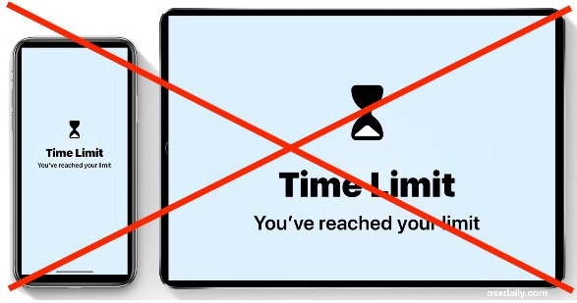

The fourth way is for the younger one’s set some rule for them in order to follow them and it also sets a boundaries between phone and social time.

Lastly as early as 5 y/o talk to them on what is the importance of socializing and also what are the effects of video games in their little minds.

Video games can entertain us it helps us to kill time and also it gives joy. There are also people who makes a living using video games but we need to manage our time. Sometimes a little too much can harm us.

1 / -  
2 louie  
3   
4 noah  
5 / jin -  
6   
7 / gilbert  
8 rogie  
9 / andrea  
10 / ash